**Mr. Visca’s: Calculus (Chpt 2.1)**

**Chpt 2 – Day 3 Limits Graphically**

**Limit by Substitution with “0” denominator**

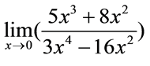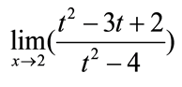

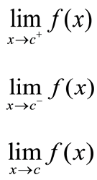

1 sided: limit of f of x as x approaches c __________________________

1 sided: limit of f of x as x approaches c __________________________

2 sided: limit of f of x as x approaches c __________________________

**Limit Graphically: One sided & Two Sided Limits**

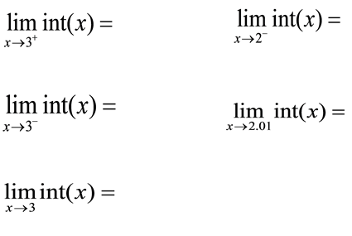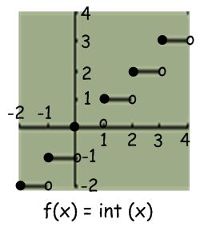

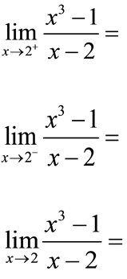

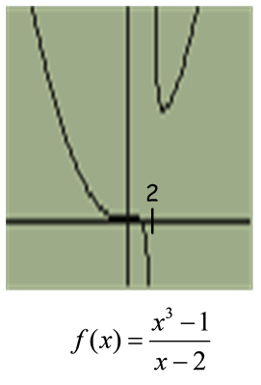

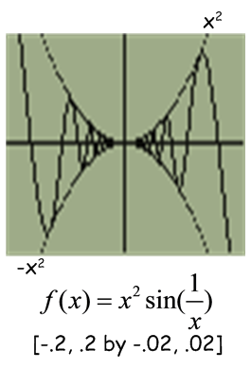

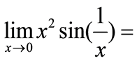

Theorem: if a function is sandwiched inbetween two other functions, the sandwiched function's ___________ is the same as the _____________ functions.

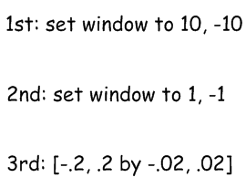I say: "just look at your table with x values ______________ close to x value in limit

*HW: Sec 2.1 #s 16,18,22,23, 24*

*26, 37, 42, 43*